Step-by-Step:

Create Customer Mailing Labels

In Excel

| july-20 |

**Document Overview**

**Documentation Goals**

This documentation is intended to provide step by step instruction for ***Creating Custom Mailing Labels using Excel and Word****.*

**Table of Contents**

**Overview** 2

**Step One: Prepare Worksheet Data** 4

**Step Two: Configure Labels** 5

Overview 5

Configuration Steps 5

Interrupt/Resume Mail Merge 7

**Step Three: Link Worksheet Data** 8

Link to Labels 8

**Step Four: Define Recipient List** 9

Recipient Inclusion 9

**Step Five: Populate Placeholders** 11

Address Placeholders 11

What Happens Upon Merge 12

Working with Fields: Examples 12

Merge Tips 16

**Step Six: Preview and Print Labels** 17

Preview Mail Merge 17

Complete Mail Merge 18

Print Labels 18

Change Individual Labels 18

**Step Seven: Save Labels** 18

Future Use 18

# **Overview**

The *Mailing List* screen is located in the following Menu Path: Accounts Receivable -> Reports for Receivables -> AR Mailing List. Alternatively, the user can quickly get to this screen using the Hot Key combination: ***[“A” – “R” – “7”]***.

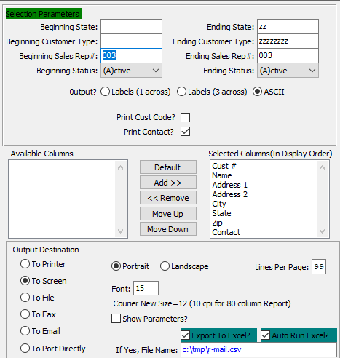

On this screen, the user can create their Excel customer list by using the ***ASCII*** output option to export and save their file in Excel.



The user can accomplish this by making sure that the *Export to Excel* and *Auto Run Excel* toggle boxes are checked.



If the user wishes to send a mass mailing to an address list that they maintain in a Microsoft Office Excel worksheet, they can use a Microsoft Office Word *mail merge*. The *mail merge* process creates a sheet of mailing labels that the user can print, and each label on the created sheet contains an address from the list.

To create and print the mailing labels, the user must first prepare the worksheet data in Excel, and then use Word to configure, organize, review, and print the mailing labels.

Please Note: If Microsoft Office Access is installed on the user’s computers, they can instead export their address list from Excel to Access, and then use Access to create and print mailing labels. For more information, see the following link: [Exchange (copy, import, export) data between Excel and Access](ms-help://MS.EXCEL.12.1033/EXCEL/content/HA10096300.htm) and [Create mailing labels in Access](ms-help://MS.EXCEL.12.1033/EXCEL/content/HA10007352.htm).

# **Step One: Prepare Worksheet Data**

Prepare the worksheet data in Excel for the *mail merge.*

## Excel Preparation

In Excel, the user’s address list must match the tabular structure that *mail merge* requires.

### One: Arrange the Address List

On a worksheet, do the following to arrange the address list:

* Use column headers that clearly identify the type of data that each column contains.  
    
  For Example: Use column headers such as the following:

|  |  |  |  |  |
| --- | --- | --- | --- | --- |
| Instead Of: | Column 1 | Column 2 | Column 3 | Column 4 |
| Use: | First Name | Last Name | Address | City |

* Use a separate column for each element that they want to include in the mail merge.  
    
  Please Note: The user can also use the *mail merge* to create form letters that address each recipient by their first name, if the users stores first and last names in separate columns. The user can also add a separate column for a title, such as Mr. or Ms.
* Include only rows and columns that contain data. Do not include blank rows or columns in the address list, because the list of labels that is created might not be complete beyond the blank rows and columns when they set up the labels for the mail merge in Word.

### Two: Define Address List Name

To help locate and select the address list during the mail merge, do the following to define a [name (name: A word or string of characters that represents a cell, range of cells, formula, or constant value. Use easy-to-understand names, such as Products, to refer to hard to understand ranges, such as Sales!C20:C30.)](javascript:AppendPopup(this,'IDH_xldefName_2_2')) for the address list:

* On the worksheet, select the whole address list, including the cells that contain column headers.
* On the ***Formulas*** tab, in the ***Defined Names*** group, click ***Define Name***.  
    
  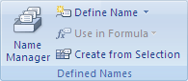
* In the ***Name*** box, type a name for the address list, such as ***Holiday Cards***, and then click “***OK”***.  
    
  Please Note: The first character of a name must be a letter, and the user cannot use a space between words. Instead of a space, use an underscore character (_).
* Save and close the workbook.

# **Step Two: Configure Labels**

Configure the labels for the *mail merge* in Word.

## Overview

The user can configure the layout of the labels just once, for all the labels in the *mail merge*. In a *mail merge*, the document that the user configures for the layout is referred to as the main document for labels (or label main document). In this document, the user can also configure any content that they wish repeated on each label, such as a company logo or their return address on shipping labels.

Chances are that the user already has a package of label sheets from one of the label sheet suppliers such as *Avery*, *AOne*, or *Formtec*. Each label sheet is a certain size and contains a certain number of labels with specific dimensions.

To configure the label main document, the user must match its dimensions with the dimensions of the labels on the worksheets that they plan to use.

## Configuration Steps

### One: Mail Merge

* By default, a blank document opens. Leave it open. If the user closes it, the commands in the next step are not available.
* On the ***Mailings*** tab, click ***Step by Step Mail Merge Wizard*** and follow steps. Alternatively, on the ***Mailings*** tab, in the ***Start Mail Merge*** group, click ***Start Mail Merge***.  
    
  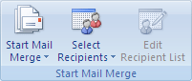

### Two: Configure Label Options

* 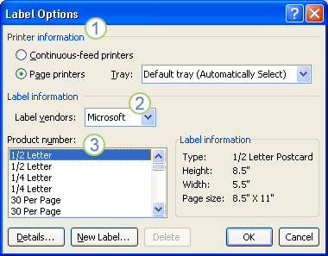Click ***Labels*.** In the ***Label Options*** dialog box, the user has several choices to make.  
    
    
  1. The type of printer that the user is using to print the labels.
  2. The supplier that produced the user’s label sheets.
  3. The number that corresponds to the product number listed on the user’s package of label sheets.

### Three: If Product Number Not Available

If the product number for the user’s label sheets does not match any one of the choices in the *Label Options* dialog box.

* The user should measure the labels on the sheet that they are using, and note the measurements and how many labels fit on a single sheet.  
    
  Please Note: Measure the labels carefully. The actual label size might be smaller than the size that is indicated by the label manufacturer. For example, a 1-by-2-inch label might actually be 15/16-inch high and 1 15/16-inches wide.
* In the ***Product Number*** list, the user should select a label type that is similar in size to their labels.  
    
  Please Note: If the user does not see a substitute label type that they can use in the ***Product Number*** box, they still might be able to use another one of the listed labels. If the user does not see a label type that fits their needs, the user can create a new label size.
* Click ***Details***, and then compare the label dimensions and the number of labels per sheet (for labels printed on laser and ink-jet printers, also referred to as page printers) or the number of columns on the label form (for labels printed on dot-matrix printers, also referred to as continuous-feed printers).
* Do one of the following:
  + If the dimensions and label layout match those of the user’s labels, use the selected label.
  + If the dimensions and layout do not match the user’s labels, click ***Cancel*.**
* In the ***Label Options*** dialog box, click the printer type (either ***Continuous-feed printers*** or ***Page printers***), and then click ***New Label*.**
* Type a name in the ***Label name*** box, select the height, width, margins, and other options for the label, and then click ***OK*.**Please Note: The new label appears in the ***Product number*** box as **Label name - Custom**. The label is also added to the ***Other/Custom*** category. The next time that the user uses their custom labels, make sure that the user selects ***Other/Custom*** in the ***Label vendors*** list

### Four: Confirm Selections

After the user has selected the label options that they want, click ***OK*.**

Word creates a document that uses a table to lay out the labels. If the user does not see lines separating the labels in the layout, click the ***Layout*** tab under ***Table Tools***, and then in the ***Table*** group, click ***View Gridlines.***

## Interrupt/Resume Mail Merge

If the user needs to interrupt their work on a mail merge, they can save the label main document just as one would any other document and resume the merge later. Word retains the data source and field information in the document that the user saves. If the user was using the ***Mail Merge*** task pane when they stopped working on the merge, Word returns to their place in the task pane when the user resumes the merge.

### One: Open Document

When the user is ready to resume the merge, open the label main document that was saved.

Word displays a message box that asks the user to confirm that they want to open the document and run an SQL command (the SQL command connects Word to their Excel source file).

### Two: Connect Excel Source

Click “***Yes”*** to connect to the Excel source file and retrieve the address list.

The text of the user’s label main document, along with any fields that were inserted, appears.

### Three: Resume Work

Click the ***Mailings*** tab, and resume work.

# **Step Three: Link Worksheet Data**

Link the worksheet data to the labels in the mail merge*.*

## Link to Labels

To merge the address information into chosen labels, the user must connect the labels to the worksheet that contains the user’s address list.

### One: First Time Connection

If this is the first time that the user has ever connected to a worksheet, do the following:

* Click the ***Microsoft Office Button*** Button image, and then click ***Word Options***
* Click ***Advanced*.**
* Scroll to the ***General*** section, and select the ***Confirm file format conversion on open*** check box.
* Click “***OK”*.**

### Two: Use Existing List

With the mail merge main document open, in the ***Start Mail Merge*** group on the ***Mailings*** tab, click ***Select Recipients***, and then click ***Use Existing List*.**



### Three: Select Data Source

Locate the Excel worksheet in the ***Select Data Source*** dialog box, and double-click it.

### Four: Confirm Data Source

In the ***Confirm Data Source*** dialog box, click ***MS Excel Worksheets via DDE (*.xls)****,* and then click “***OK”*.**

Please Note: If the user does not see ***MS Excel Worksheets via DDE (*.xls)*** in the list, select the ***Show all*** check box.

### Five: Select Excel

In the ***Microsoft Office Excel*** dialog box, for ***Named or cell range***, select the cell range or worksheet that contains the information that the user desires to merge, and then click “***OK”*.**

### Six: Finalize

The labels are now connected to the worksheet data, but the sheet of labels is still blank. If needed, the user can define the list of recipients as described in (Step 4), or the user can start populating the labels with placeholders for the address information, as described in (Step 5).

# **Step Four: Define Recipient List**

Define the list of recipients that the user wishes to include on the labels.

## Recipient Inclusion

Word generates a label for each address in the user’s mailing list. If the user wishes to generate labels for only certain addresses in the mailing list, the user can choose which addresses (records) to include.

To narrow the list of recipients or to use a subset of the records in the user’s data file, do the following:

### One: Open Recipient List

On the ***Mailings*** tab, in the ***Start Mail Merge*** group, click ***Edit Recipient List*.**



### Two: Recipient Dialogue Box

In the ***Mail Merge Recipients*** dialog box, do one of the following:

#### Option One: Select Individual Records

This method is most useful if the list is short. Select the check boxes next to the recipients that the user wants to include, and clear the check boxes next to the recipients that the user wants to exclude.

Please Note: If the user knows that they want to include only a few records in the merge, the user can clear the check box in the header row and then select only those records that they want. Similarly, if the user wants to include most of the list, select the check box in the header row, and then clear the check boxes for the records that the user does not want to include.

#### Option Two: Sort Records

Click the heading of the column that the user wants to sort by. Word sorts the list in ascending alphabetical order (from A to Z). Click the column heading again to sort the list in descending alphabetical order (Z to A).

To specify more advanced sorting options, click ***Sort*** under ***Refine recipient list*** and select the sorting preferences on the ***Sort Records*** tab in the ***Filter and Sort*** dialog box. For example, the user can specify that recipient addresses must be alphabetized by last name within each postal code, and that postal codes are listed in numeric order.

#### Option Three: Filter Records

This method is useful if the list contains records that the user does not want to see or include in the merge. After the user filters the list, the user can select or clear the check boxes to include or exclude specific records.

To filter records, do the following:

1. Under ***Refine recipient list***, click ***Filter*.**
2. On the ***Filter Records*** tab in the ***Filter and Sort*** dialog box, select the criteria that the user wishes to use to filter the records.  
     
   For example, to generate labels only for addresses in Australia, click ***Country or Region*** in the ***Field*** list, ***Equal to*** in the ***Comparison*** list, and ***Australia*** in the ***Compare to*** list.
3. To further refine the filter, click “***And”*** or “***Or”***, and then select more criteria.  
     
   For example, to generate labels only for businesses in Munich, the user specifies records whose ***City*** field contains ***Munich*** and whose ***Company Name*** field is not blank. If the user uses “**Or”** instead of “***And”*** in this filter, the mail merge includes all Munich addresses in addition to all addresses that include a company name, regardless of city.

### Three: Recipient Address Validation Software

If the user has installed address validation software on their computer, the user can click ***Validate addresses*** in the ***Mail Merge Recipients*** dialog box to validate the recipients' addresses.

# **Step Five: Populate Placeholders**

Populate the labels with placeholders for address information.

## Address Placeholders

When the user performs the mail merge, the mail merge fields are filled with information from the address list.

After the user connects their labels to the address list, the user is ready to add placeholders that indicate where the addresses will appear on each label. The user can also type text that they want repeated on each label, such as a company logo or their return address on a shipping label.

The placeholders for the addresses are called *mail merge fields*. Mail merge fields in Word correspond to the column headers in the data file that is chosen.

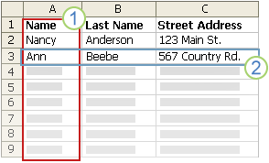

1. Columns in a data file represent categories of information. Mail merge fields that the user adds to the labels are placeholders for these categories.
2. Rows in a data file represent records of information. Word generates a label for each record when the user performs a mail merge.

By putting a mail merge field in the original label that the user configured in the label main document, the user indicates that they want a certain category of information, such as name or address, to appear in that location.

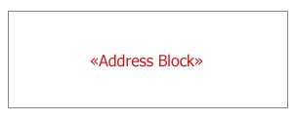

Please Note: When the user inserts a mail merge field into the label main document, the field name is always surrounded by chevrons (« »). These chevrons do not show up on the final labels — they just help distinguish the fields in the label main document from the regular text.

### What Happens Upon Merge

When the user performs the mail merge, information from the first row in the data file replaces the fields in the first label. Then, information from the second row in the data file replaces the fields in the second label, and so on.

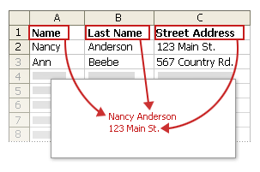

### Working with Fields: Examples

When the user designs labels, they can link any column heading from their data file to a field in a label.

For example, suppose the user has a subscriber list to their newsletter, and the data file includes a column, called ExpireDate, that stores the date that each subscription expires. If the user inserts an «ExpireDate» field in the label main document before they run the merge, that information is added to each mailing label.

the user can combine fields and separate them with punctuation marks. For example, to create an address, the user can configure the fields in the label main document as follows:

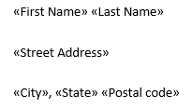

For combinations that the user uses frequently, like address blocks and greeting lines, Word provides composite fields that group a number of fields together. For example, the Address Block field is a combination of several fields, including first name, last name, street address, city, and postal code.

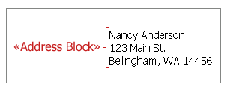

the user can customize the content in each of these composite fields. For example, in the address, the user may want to select a formal name format (**Mr. Roger Harui**). In the greeting, the user might prefer to use "To" instead of "Dear."

### One: Map the Mail Merge Fields to the Data File

To make sure that Word can find a column in the data file that corresponds to every address element, the user might need to map the mail merge fields in Word to the columns in their data file.

To map the fields, click ***Match Fields*** in the ***Write & Insert Fields*** group on the ***Mailings*** tab.

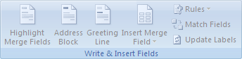

The ***Match Fields*** dialog box appears.

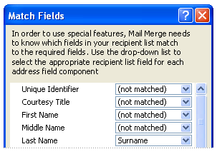

The elements of an address are listed on the left. Column headings from the data file are listed on the right.

Word searches for the column that best matches each element. As the graphic illustrates, Word automatically matched the data file's ***Surname*** column to ***Last Name***, but Word was unable to match other elements, such as ***First Name*.**

In the list on the right, the user can select the column from the data file that matches the element on the left. In the graphic, the ***Name*** column is now matched with ***First Name***. It is okay that ***Courtesy Title***, ***Unique Identifier***, and ***Middle Name*** are not matched, because the mail merge label does not need to use every field. If the user adds a field that does not contain data from the data file, it will appear in the merged document as an empty placeholder — usually a blank line or an empty block of space.

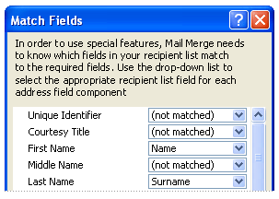

### Two: Type the Content and Add the Fields

* In the original label that the user configured in the label main document, the user may click where they want to insert the field.
* Use the ***Write & Insert Fields*** group on the ***Mailings*** tab.  
    
  
* Add any of the following:

1. Click ***Address Block*.**
2. In the ***Insert Address Block*** dialog box, select the address elements that the user wants to include and the formats that the user wants to apply, and then click “***OK”*.**
3. If the ***Match Fields*** dialog box appears, this means that Word is unable to find some of the information that it requires to complete the address block. Click the arrow next to **(*not matched*)**, and then select the field from the data source that corresponds to the field that is required for the mail merge.
4. On the ***Mailings*** tab, in the ***Write & Insert Fields*** group, click ***Insert Merge Field*.**
5. In the ***Insert Merge Field*** dialog box, do one of the following:  
   * To select address fields that will automatically correspond to fields in the data source, even if the names of those fields are not the same as the field names in Word, click ***Address Fields*.**
   * To select fields that always take data directly from a column in the data file, click ***Database Fields*.**
6. In the ***Fields*** box, click the field that the user wants.
7. Click ***Insert***, and then click ***Close*.**
8. If the ***Match Fields*** dialog box appears, this means that Word is unable to find some of the information that it requires to insert the field. Click the arrow next to **(*not matched*)**, and then select the field from the data source that corresponds to the field that is required for the mail merge.
9. In Outlook Contacts, on the ***View*** menu, point to ***Current View***, and then click ***Phone List*.**
10. Right-click a column heading, and then click ***Field Chooser*.**
11. In the drop-down list at the top of the ***Field Chooser*** dialog box, select ***User-defined fields in folder***.
12. Drag the field that the user wants to add from the dialog box to the column headings. A little red arrow helps the user place the field in the location that they want.  
      
    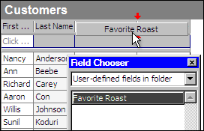  
      
    Please Note: the user can add a new field in the ***Field Chooser*** dialog box by clicking ***New*** at the bottom.
13. After the user adds all of their custom fields to the view, close the ***Field Chooser*** dialog box.
14. To remove a field that the user does not want included in the mail merge, click the field name in the column heading in Phone List view, and drag it off the column heading.
15. In Outlook Contacts, select individual contacts by holding down “***SHIFT”*** and clicking to select a range, or by holding down “***CTRL”*** and clicking to select individual contacts. If the user wants to include all the contacts currently visible in the view, do not click any contacts.
16. On the ***Tools*** menu, click ***Mail Merge*.**
17. If the user selected individual contacts to include in the mail merge, click ***Only selected contacts***. If the user wants to include all the contacts that are currently visible in the view, click ***All contacts in current view*.**
18. If the user configured the Phone List view so that it displays exactly the fields that they want to use in the mail merge, click ***Contact fields in current view***. Otherwise, click ***All contact field*s** to make all of the contact fields available in the mail merge.
19. To generate a new main document for the mail merge, click ***New document***. Otherwise, click ***Existing document***, and then click ***Browse*** to locate the document to use as the main document.
20. To save the contacts and fields that the user selected so that they can be reused, select the ***Permanent file*** check box, and then click ***Browse***. Outlook saves the data in a Word document (.doc or .docx for Word 2007 or later) as comma-delimited data.
21. Select ***Mailing Labels*.**
22. Click “***OK”***. After the document opens in Word, on the ***Mailings*** tab, in the ***Write & Insert Fields*** group, click the arrow next to ***Insert Merge Field***, and then click the fields that they want to add to the label main document.

* After the user finishes setting up the first label the way they want it, in the ***Write & Insert Fields*** group, click ***Update Labels***Word replicates the layout of the first label to all the other labels

### Merge Tips

* the user cannot type merge field characters (**«« »»**) manually or use the ***Symbol*** command on the ***Insert*** menu in Word. The user must use mail merge.
* If the merge fields appear inside braces, such as **{** *MERGEFIELD* City **}**, Word is displaying [field codes (field code: Placeholder text that shows where specified information from your data source will appear; the elements in a field that generate a field's result. The field code includes the field characters, field type, and instructions.)](javascript:AppendPopup(this,'offieldcode_3_3')) instead of [field results (field results: Text or graphics inserted in a document when Microsoft Word carries out a field's instructions. When you print the document or hide field codes, the field results replace the field codes.)](javascript:AppendPopup(this,'wodefFieldResult_4_4')). This doesn't affect the mail merge, but if the user wants to display the results instead, right-click the field code, and then click ***Toggle Field Codes*.**

### Three: Format the Merged Data

Database and spreadsheet programs, such as Access and Excel, store the information that the user types in cells as *raw data*. Formatting, such as fonts and colors, that the user applies in Access or Excel is not stored with the raw data. When the user merges information from a data file into a Word document, they are merging the raw data without the applied formatting.

To format the data in the document, select the mail merge field and format it, just as the user would format any text. Make sure that the selection includes the chevron characters (**« »**) that surround the field.

# **Step Six: Preview and Print Labels**

After the user has added the fields to the original label that they configured in the label main document, the user is ready to preview the mail merge results. After the user is satisfied with the preview, they complete the mail merge and print the labels. The user can then save the label main document for future use.

## Preview Mail Merge

The user can preview their labels and make changes before they actually complete the mail merge.

To preview, do any of the following in the ***Preview Results*** group of the ***Mailings*** tab:

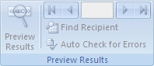

* Click ***Preview Results***
* Page through each label by clicking the ***Next Record*** and ***Previous Record*** buttons in the ***Preview Results*** group on the ***Mailings*** tab.
* Preview a specific label document by clicking ***Find Recipient*.**

### Note: Filter Recipients

Click ***Edit Recipient List*** in the ***Start Mail Merge*** group on the ***Mailings*** tab to open the ***Mail Merge Recipients*** dialog box, where the user can filter the list or remove recipients from the merge if the user sees records that they do not want to include.



### Note: Word Table

Word uses a table to lay out a sheet of labels on the page. As the user pages through the labels, the active record is displayed in the first cell of the table, with the following records displayed in subsequent cells.

## Complete Mail Merge

### Print Labels

To print the labels, do the following:

#### One: Finish and Print

On the ***Mailings*** tab, in the ***Finish*** group, click ***Finish & Merge***, and then click ***Print Documents*.**

#### Two: Choose Labels

Choose whether to print the whole set of labels, only the label that is currently visible, or a specific subset of the labels.

### Change Individual Labels

To change individual labels, do the following:

#### One: Edit Document

On the ***Mailings*** tab, in the ***Finish*** group, click ***Finish & Merge***, and then click ***Edit Individual Documents*.**

#### Two: Choose Labels

The user may choose whether they want to edit the whole set of labels, only the label that is currently visible, or a specific subset of the labels. Word saves the labels that they want to edit to a separate file.

# **Step Seven: Save Labels**

Save the labels for future use.

## Future Use

Remember that the merged labels that are saved are separate from the original label that the user configured in the label main document. It is a good idea to save the label main document itself if the user plans to use it for another mail merge.

When the user saves the label main document, they also save its connection to the data file. The next time that they open the label main document, Word will prompt the user to choose whether or not to merge the information from the data file into the label main document again.

#### Yes

If the user clicks “***Yes”***, the document opens with the information from the first record that was merged in.

#### No

If the user clicks “***No”***, Word breaks the connection between the label main document and the data file, reformats the label main document as a standard Word document, and replaces the fields with the unique information from the first record.